Laboratory 1:

Link to the BigQuery queries (all eleven prompt):
https://console.cloud.google.com/bigquery?ws=!1m7!1m6!12m5!1m3!1spurdue-ms-ds-bruno-cavagnaro!2sus-central1!3sec55d4a6-9c9a-44ab-b252-6d7c3c943a7e!2e1

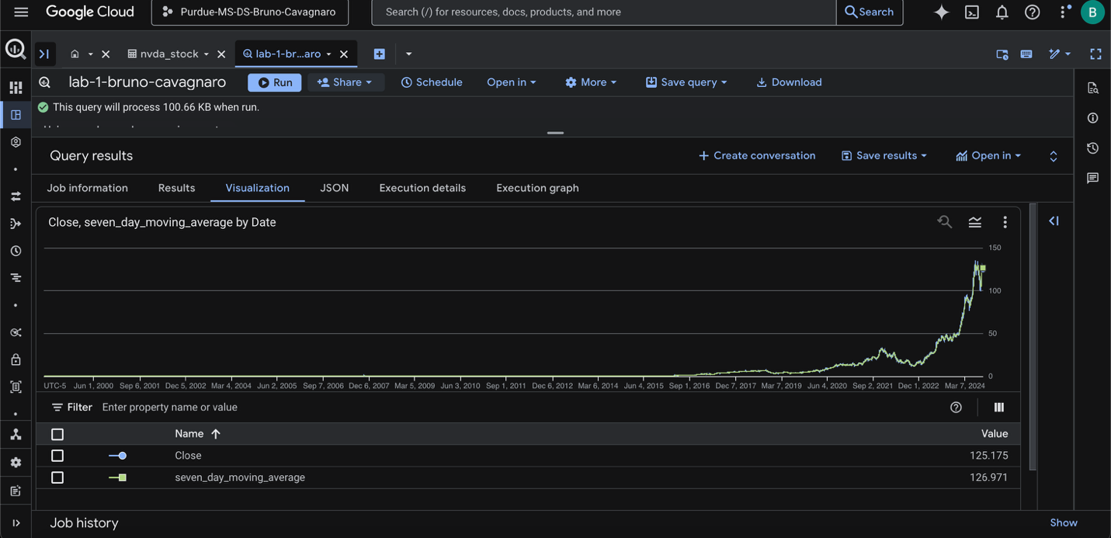

LIST OF QUERIES:

--- First query - data cleaning of 0

SELECT
Date,
Open,
High,
Low,
Close,
Volume,
COALESCE(Dividends, 0) AS Dividends,
COALESCE(`Stock Splits`, 0) AS `Stock Splits`
FROM `purdue-ms-ds-bruno-cavagnaro.lab1_eda.nvda_stock`
LIMIT 1000;

--- Second query - data cleaning of 0

SELECT
CAST(Date AS DATE) AS Date,
Open,
High,
Low,
Close,
Volume,
COALESCE(Dividends, 0) AS Dividends,
COALESCE(`Stock Splits`, 0) AS `Stock Splits`
FROM `purdue-ms-ds-bruno-cavagnaro.lab1_eda.nvda_stock`
LIMIT 1000;

-- Third query - Identify outliers

SELECT
t1.*,
(t1.Close - t2.avg_close) / t2.stddev_close AS z_score_close,
(t1.Volume - t2.avg_volume) / t2.stddev_volume AS z_score_volume
FROM
`purdue-ms-ds-bruno-cavagnaro.lab1_eda.nvda_stock` AS t1,
(
SELECT
AVG(Close) AS avg_close,
STDDEV(Close) AS stddev_close,
AVG(Volume) AS avg_volume,
STDDEV(Volume) AS stddev_volume
FROM `purdue-ms-ds-bruno-cavagnaro.lab1_eda.nvda_stock`
) AS t2
WHERE
ABS((t1.Close - t2.avg_close) / t2.stddev_close) > 3
OR ABS((t1.Volume - t2.avg_volume) / t2.stddev_volume) > 3
ORDER BY Date;

-- Fourth query - Check for duplicate records

SELECT
t.`Date`,
t.Open,
t.High,
t.Low,
t.Close,
t.Volume,
t.Dividends,
t.`Stock Splits`,
COUNT(*) AS record_count
FROM `purdue-ms-ds-bruno-cavagnaro.lab1_eda.nvda_stock` AS t
GROUP BY
t.`Date`, t.Open, t.High, t.Low, t.Close, t.Volume, t.Dividends,
t.`Stock Splits`
HAVING COUNT(*) > 1
ORDER BY t.`Date`

-- Fifth query - Average values for all numerical columns

SELECT
AVG(t.Open) AS avg_open,
AVG(t.High) AS avg_high,
AVG(t.Low) AS avg_low,
AVG(t.Close) AS avg_close,
AVG(t.Volume) AS avg_volume,
AVG(t.Dividends) AS avg_dividends,
AVG(t.`Stock Splits`) AS avg_stock_splits
FROM `purdue-ms-ds-bruno-cavagnaro.lab1_eda.nvda_stock` AS t;

-- Sixth Query - Average values of numeric columns for a specific year like 2023

SELECT
AVG(t.Open) AS average_open,
AVG(t.High) AS average_high,
AVG(t.Low) AS average_low,
AVG(t.Close) AS average_close,
AVG(t.Volume) AS average_volume,
AVG(t.Dividends) AS average_dividends,
AVG(t.`Stock Splits`) AS average_stock_splits
FROM `purdue-ms-ds-bruno-cavagnaro.lab1_eda.nvda_stock` AS t
WHERE EXTRACT(YEAR FROM t.Date) = 2023;

-- Seventh Query - Find the maximum and minimum by month

SELECT
DATE_TRUNC(t.Date, YEAR) AS year,
DATE_TRUNC(t.Date, MONTH) AS month,
MAX(t.Open) AS max_open,
MIN(t.Open) AS min_open,
MAX(t.High) AS max_high,
MIN(t.High) AS min_high,
MAX(t.Low) AS max_low,
MIN(t.Low) AS min_low,
MAX(t.Close) AS max_close,
MIN(t.Close) AS min_close,
MAX(t.Volume) AS max_volume,
MIN(t.Volume) AS min_volume,
MAX(t.Dividends) AS max_dividends,
MIN(t.Dividends) AS min_dividends,
MAX(t.`Stock Splits`) AS max_stock_splits,
MIN(t.`Stock Splits`) AS min_stock_splits
FROM `purdue-ms-ds-bruno-cavagnaro.lab1_eda.nvda_stock` AS t
GROUP BY DATE_TRUNC(t.Date, YEAR), DATE_TRUNC(t.Date, MONTH)
ORDER BY DATE_TRUNC(t.Date, YEAR), DATE_TRUNC(t.Date, MONTH);

-- Eith query - Counting the number of trading days

SELECT COUNT(DISTINCT Date) AS number_of_trading_days
FROM `purdue-ms-ds-bruno-cavagnaro.lab1_eda.nvda_stock`;

-- Nine query - Calculate high trading volume days

SELECT t1.date, t1.volume
FROM `purdue-ms-ds-bruno-cavagnaro.lab1_eda.nvda_stock` AS t1
WHERE
t1.volume >= (
SELECT PERCENTILE_CONT(t2.volume, 0.75) OVER ()
FROM `purdue-ms-ds-bruno-cavagnaro.lab1_eda.nvda_stock` AS t2
LIMIT 1
)
ORDER BY t1.date;

-- Ten query - calculate daily percentage count

SELECT
Date,
Close,
LAG(Close, 1) OVER (ORDER BY Date) AS previous_day_close,
(
(Close - LAG(Close, 1) OVER (ORDER BY Date))
/ LAG(Close, 1) OVER (ORDER BY Date))
* 100 AS daily_percentage_change
FROM `purdue-ms-ds-bruno-cavagnaro.lab1_eda.nvda_stock`
ORDER BY Date;

-- Eleve query - calculate the stock performance over time

SELECT
Date,
Close,
AVG(Close)
OVER (ORDER BY Date ASC ROWS BETWEEN 6 PRECEDING AND CURRENT ROW)
AS seven_day_moving_average
FROM `purdue-ms-ds-bruno-cavagnaro.lab1_eda.nvda_stock`
ORDER BY Date;

